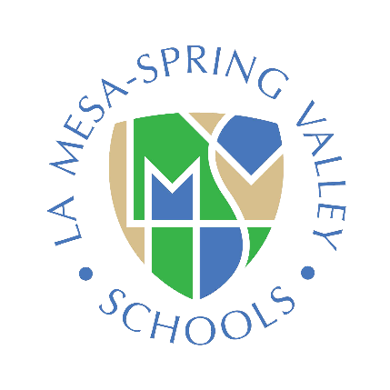

Citizens’ Bond Oversight Committee (Measure V) Meeting will be held at Spring Valley Academy August 14, 2024
Regular Meeting 5:30pm-6:30pm

1. | Opening Procedures  - Call to Order  - Establishment of Quorum | ACTION/CHAIR
2. Approval of Minutes – May 15, 2024 |  | PROCEDURAL / CHAIR
3. Public Comments
4. Report Measure V Bond Program Update |  | INFORMATIONAL COCHRAN / CLAUSSEN
- Projects
- Schedule
- Finance & Budget
- Discussion Items  - Series C Bond Sale  - Tour Spring Valley Academy Bond Work |  | DISTRICT / CHAIR
- Adjourn |  | PROCEDURAL / CHAIR

In compliance with the Americans with Disabilities Act, if you need special assistance, disability-related modifications or accommodations, including auxiliary aids or services, in order to participate in the public meetings of the CBOC, please contact the office of the Assistant Superintendent, Business Services at 619-668-5700. Notification 72 hours prior to the meeting will enable the District to make reasonable arrangements to ensure accommodation and accessibility to this meeting. Upon request, the District shall also make available this agenda and all other public records associated with this meeting in appropriate alternative formats for persons with a disability. CBOC agendas and minutes are, by law, public documents. CBOC agendas, minutes, and related documents may be found on the Measure V page of the District’s Website.

